“The Four Alls of Salvation”
Series preached by David Averill, First UMC of Mt. Dora over four Sundays in September 2022.
Series Rationale: Present Wesley's Via Salutis faithfully to the Biblical text, yet it also offers Wesleyan theology through the easy-to-understand rubric from British Methodists called the "Four Alls". The sheet attached is a bulletin insert that a preacher can reference throughout the series and during Bible studies:

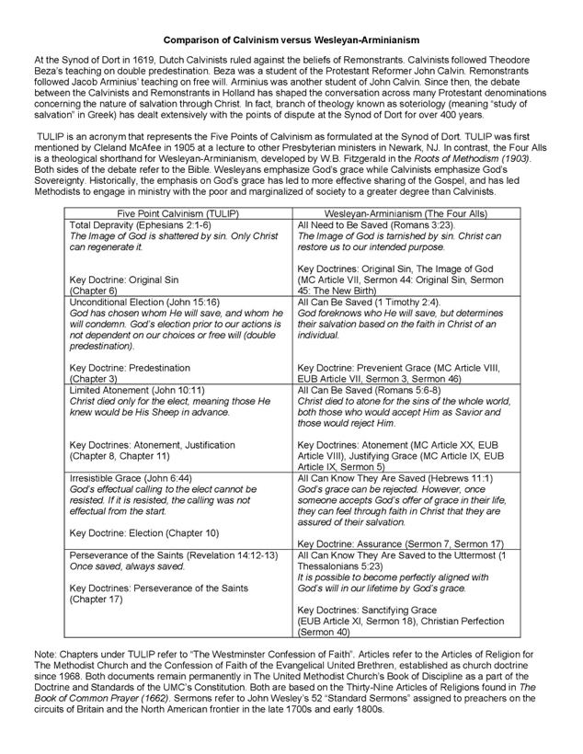

Secondarily, this theme will counter the harmful influence of Hyper-Calvinist Theology among North American Protestants, particularly popular in non-denominational and Baptist circles (due to Reformed Baptists like John Piper).
Considering anti-racism as sanctification, a fact about Hyper-Calvinism must be named. Hyper-Calvinism is all about exclusion to make a specific group of people feel superior in their standing before God. Hyper-Calvinism provides misleading theological support for Christian nationalism and white supremacists movements. Two egregious, historical examples of how this became a lived reality were in the Antebellum American South with the issue of slavery and South Africa during Apartheid with the huge influence of Afrikaner Calvinism.
On the other hand, Wesleyan-Arminian highlights the inclusive need of all God's children for the grace of God, the grace of God can change us all for the better. Historically, this is why Methodism was so well received by Black religious leaders in the 1800s like Bishop Richard Allen, one of the founders of the African Methodist Episcopal Church. These Black leaders knew this was the full gospel, even if the white Methodist of the time excluded them from the church due the structural influence of racism as part of America's original, collective sin of slavery and enslavement of primarily African-descended peoples for over 400 years against their will and without considering their God-given worth as children of God.
This God-given potential for change and redemption for all humanity through the grace of Our Lord Jesus Christ is the "grand deposit of Methodism" that John Wesley preached through word and deed in leading the Methodist revival moment in its early stages. Wesley's "way of salvation" (via salutis) describes our journey of growing closer to God in steps of receiving prevenient grace, justifying grace, and sanctifying grace. The Methodist way of salvation has inspired generations of United Methodists. An inclusive view of salvation by God's grace leads us to transform the world because we believe everyone has a chance to be redeemed by God, and everyone has a sacred worth to be redeemed by God. This is the full gospel that needs to be preached in this series.

Themes and Scriptures for the series:
1. All need to be saved - September 4 (Sin)
Romans 3:21-26
2. All can be saved - September 11 (Prevenient Grace)
1 Timothy 2:1-7
3. All can know they are saved - September 18 (Justifying Grace, Assurance, Salvation)
Hebrews 11:1-3
4. All can be saved to the uttermost (Sanctification, Christian Perfection)- September 25
1 Thessalonians 5:23-24

Four Alls Sermon Bumper Videos
(All taken from umc.org website)
Week 1: All Need to Be Saved
https://youtu.be/pvzIfqtfJ2s
Week 2: All Can Be Saved
https://www.youtube.com/watch?v=wjuD_5Ate6E
Week 3: All Can Know They Are Saved
https://youtu.be/unFwBJEwSyw
Week 4: All Can Be Saved to the Uttermost
https://youtu.be/Dl6EP-ePy4s?si=ae0xO-1uFFdCuUuw
Please see the graphic below of the Four Alls pub for the sermon banner.

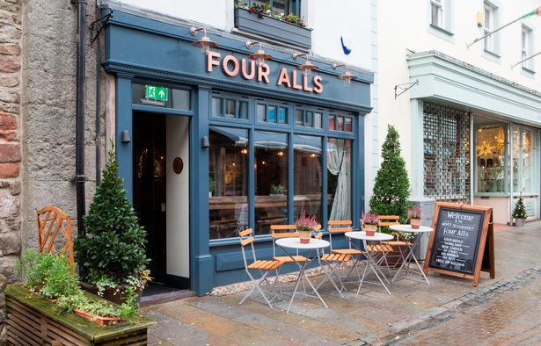
Fun Note:
I came to find out that "Four Alls" or "Five Alls" is actually a common pub name in the British Isles, dating to the 1700s.

